**Password for bandit22**

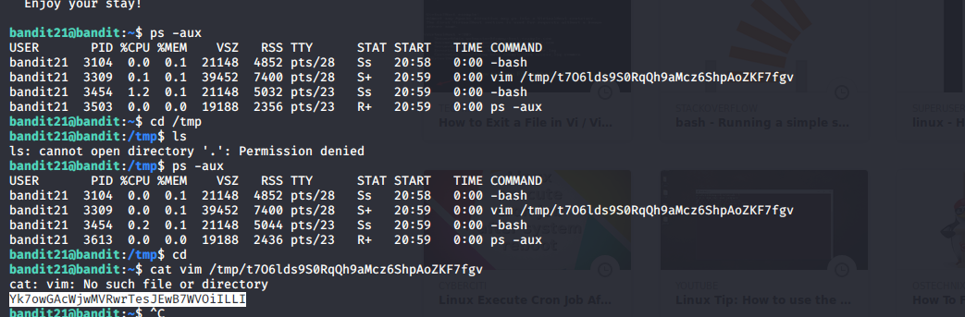

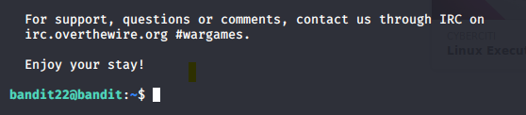

**Password for bandit23**

